To build supermarket basket project I used some sample products image to train product identification models and below are some products details screens shot

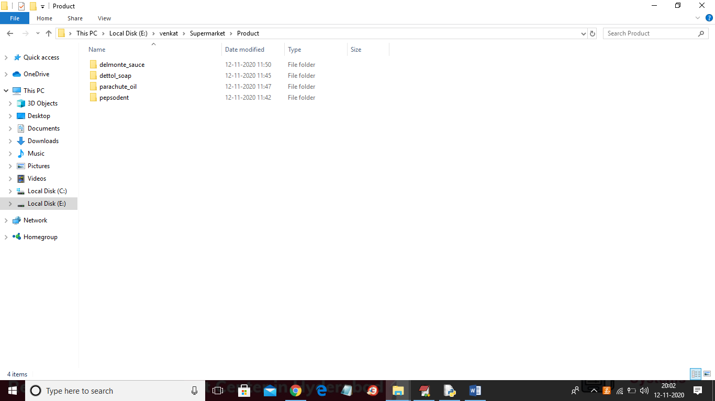

In above screen I took 4 products folders and each folder contains images of those products. For example below is the images of Dettol_soap folder

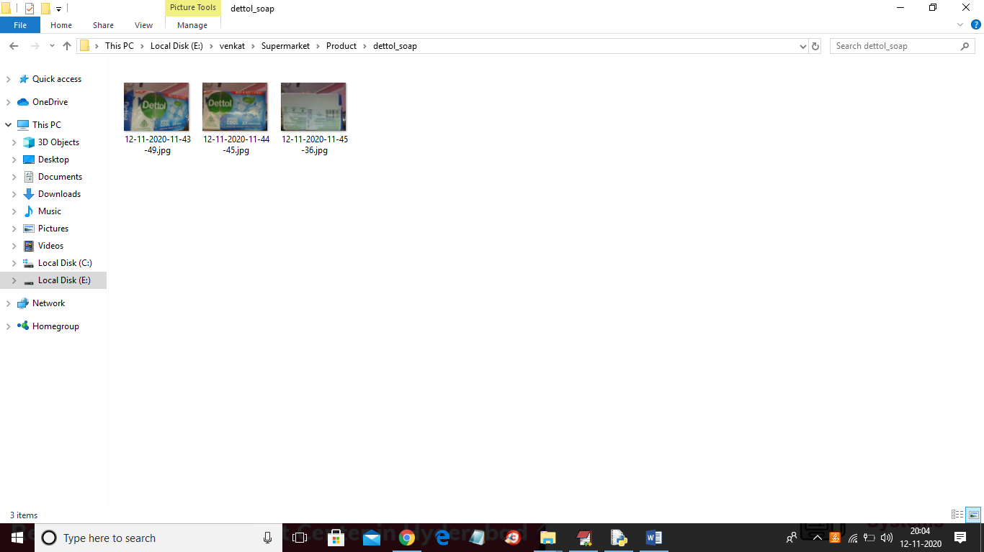

In above screens we can see Dettol images and now to identify products run the project by double click on ‘run.bat’ file to get below screen

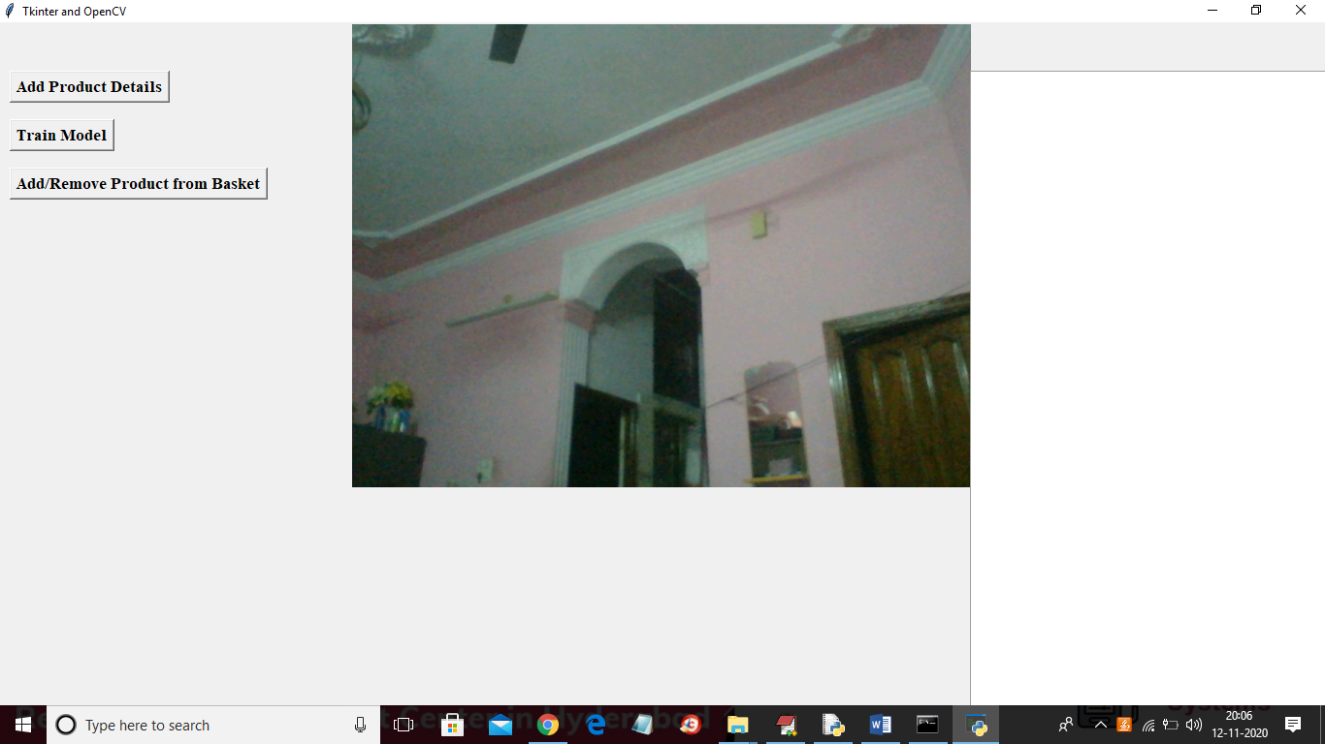

In above screen we can see application connected to web cam and now click on ‘Train Model’ button to train model with images

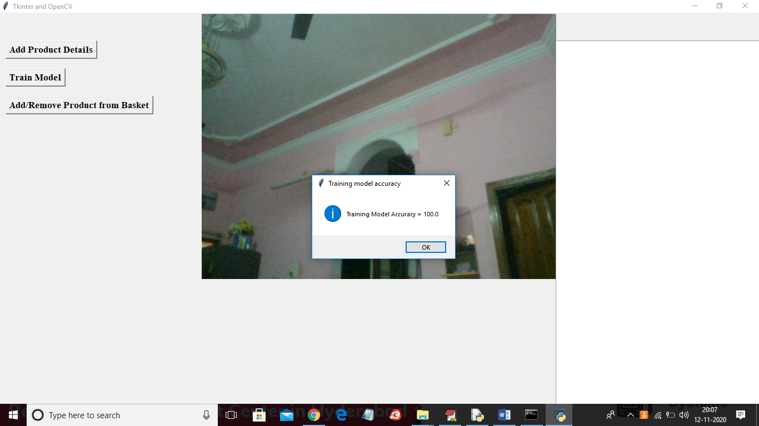

In above screen train model generated with 100% accuracy and now show product to web cam and click on ‘Add/Remove Product from Basket’ button to allow application to identify product image and then show in text area and if we again show same product then application will remove from text area.

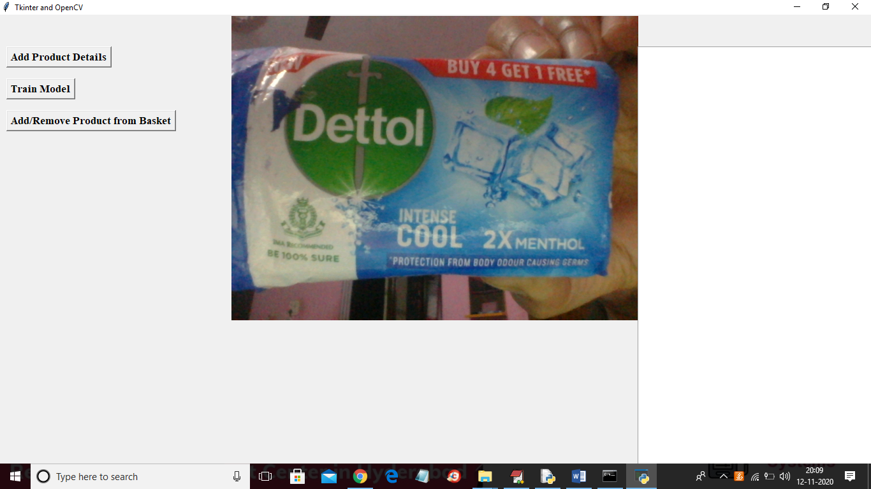

In above screen I am showing one product and after clicking on ‘Add/Remove Product from Basket’ button will get below result

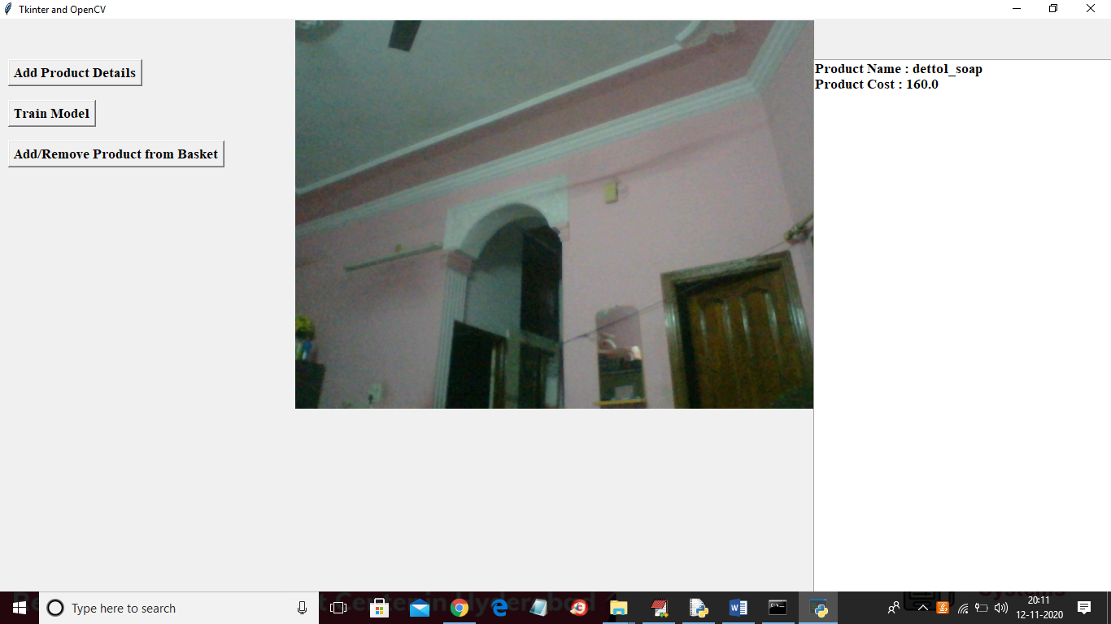

In above screen in text area we can consider as basket and the name of product and cost is displaying and now try with other product

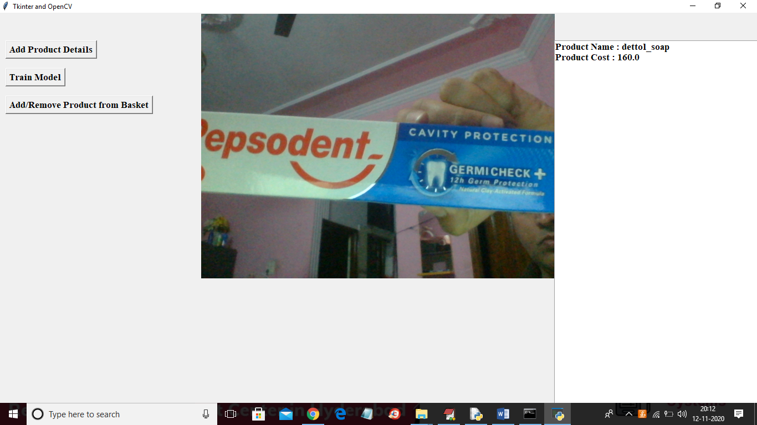

In above screen showing another image and after clicking on ‘Add/Remove Product from basket’ button will get below screen

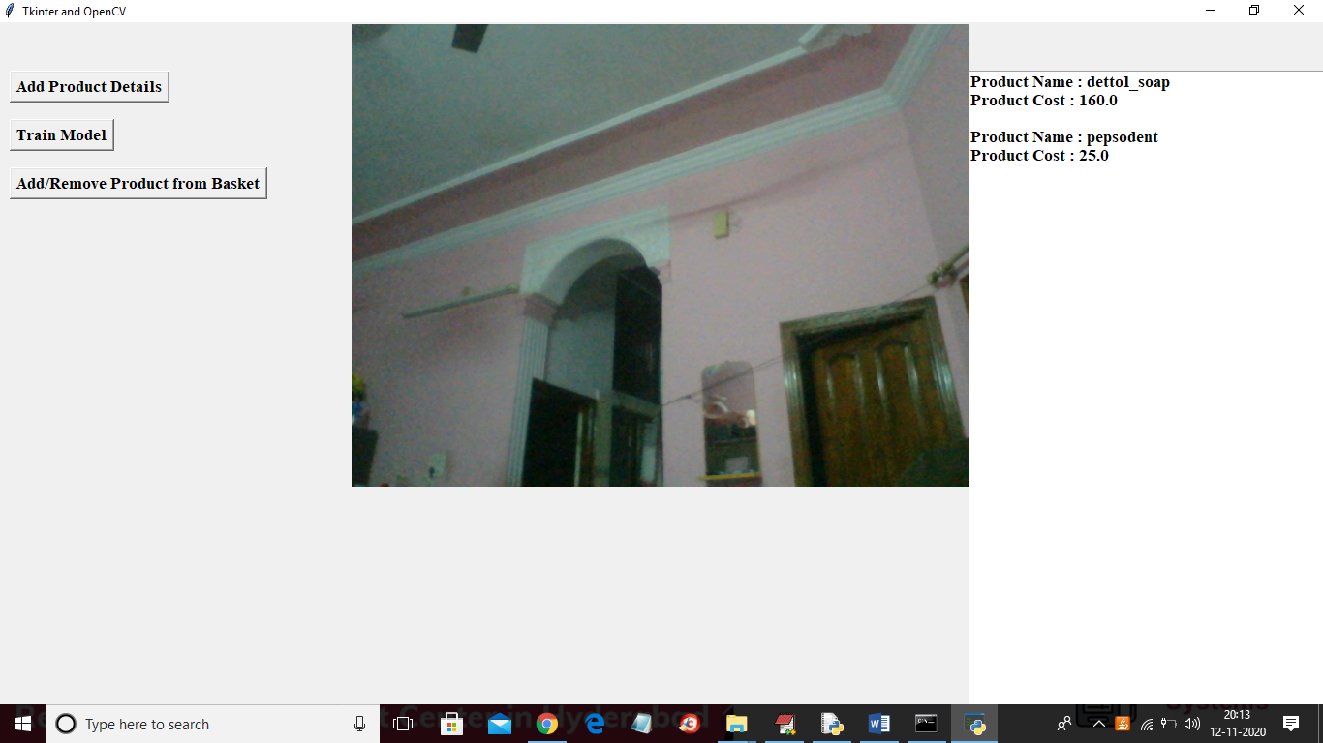

In above screen we can see two products added to basket and now show same product again to remove from basket

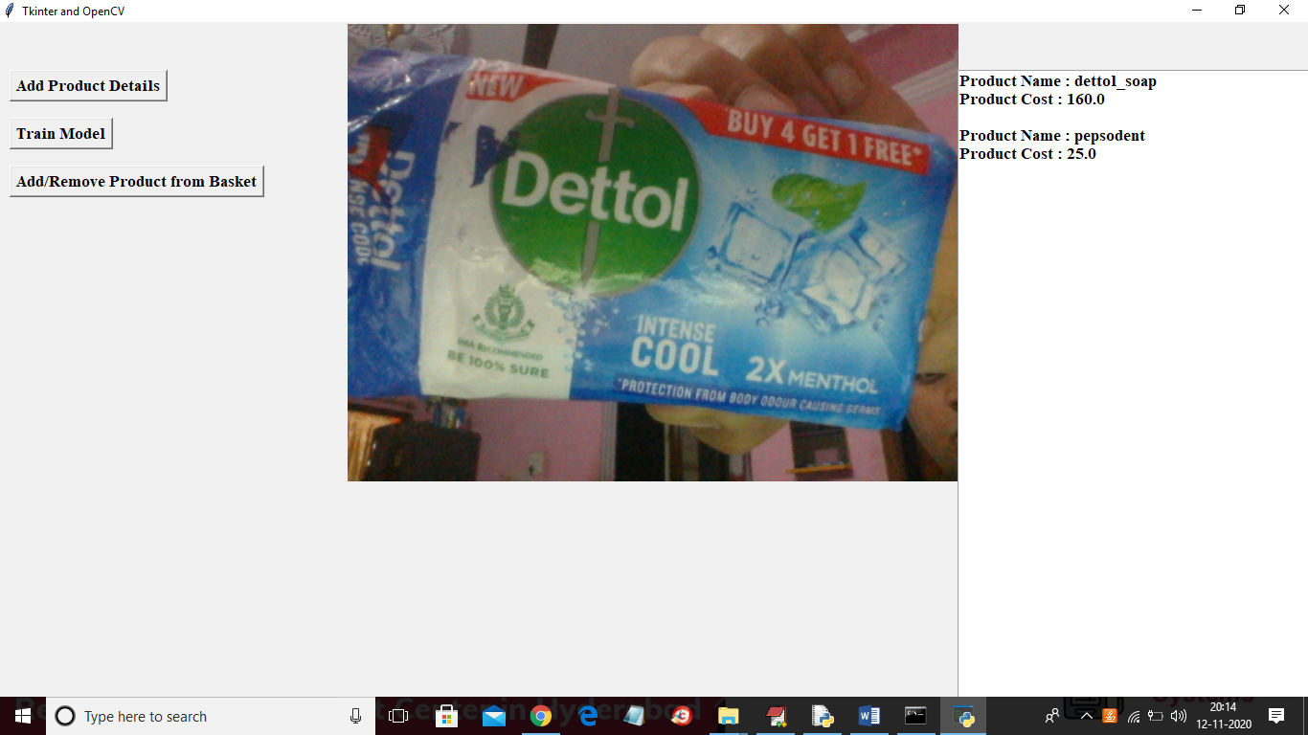

In above screen I am showing same product again and then application identified this item from basket and removed it and see the below output screen after removing item

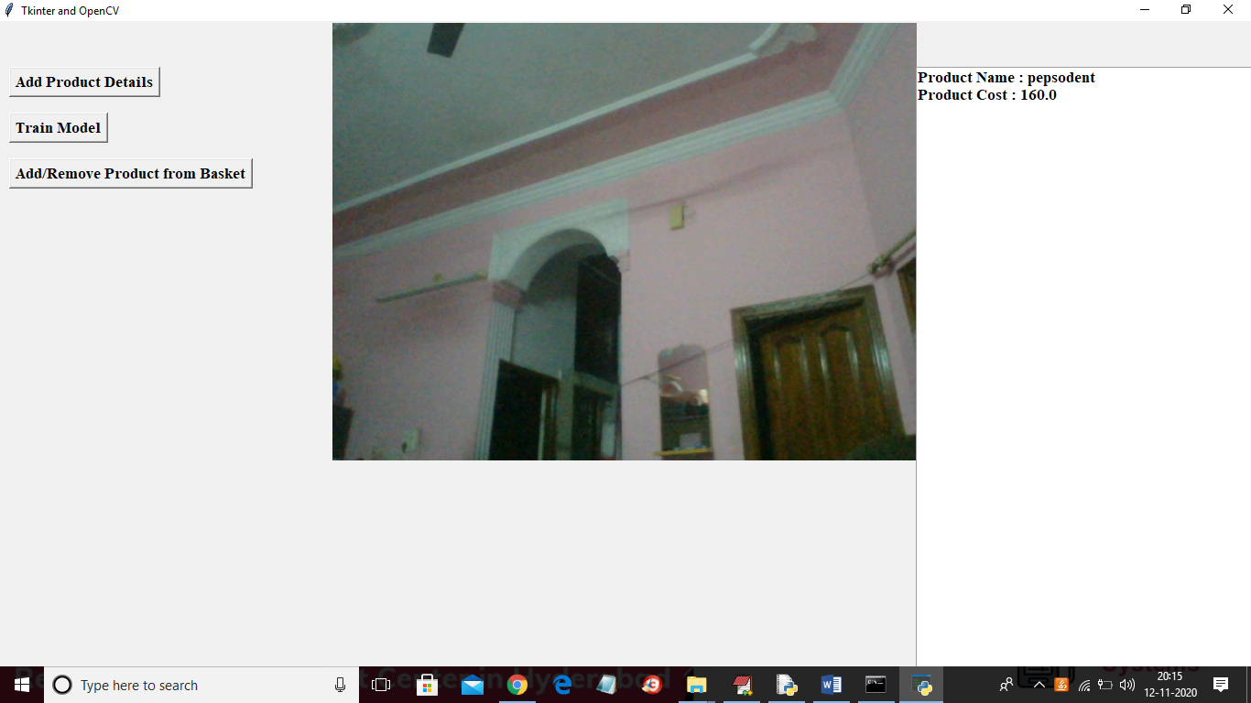

Similarly u can test with other products also and if u have new images then send to us we will rebuild model as per your image and send